Assignment

I would like to you all throughs few relationships between trader performance and market sentiments to uncover hidden patterns by delivering insights that can drive smarter trading strategies.

Which will make your trading journey smoother and make you less prone to losses if you follow the strategy. Since, these strategy is based on historical data so you can believe on it and analyse yourself as well based on this.

I would also provide the visualisation for the strategy based on data.

Strategies are:

**1.**

We can analyse the growth of top traders, based on which we can make our decisions If we are not going profitable in it.

Cumulative closed PnL is total amount of profit in millions

Now to understand the under laying patter we will zoom it to one day trade of these top trader, that how they trade in each day.

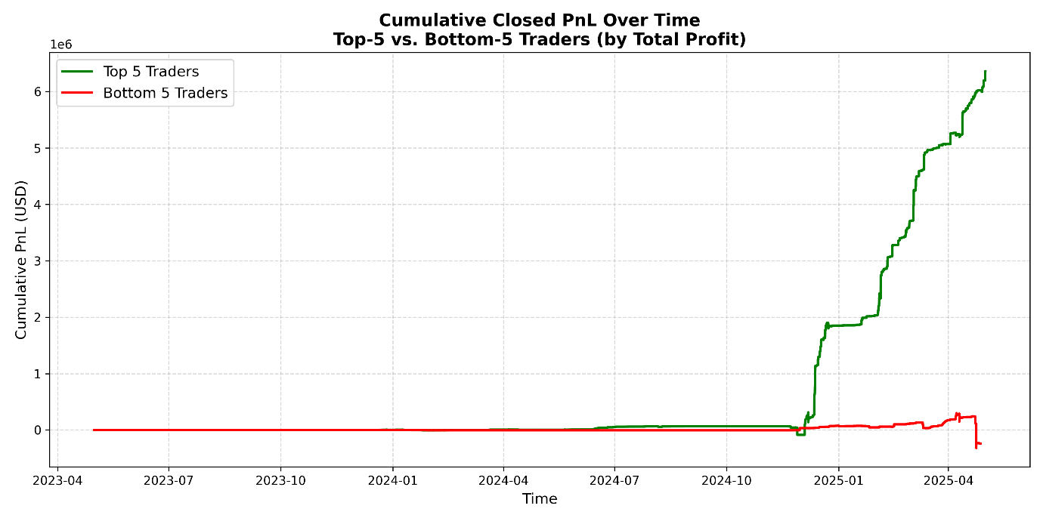

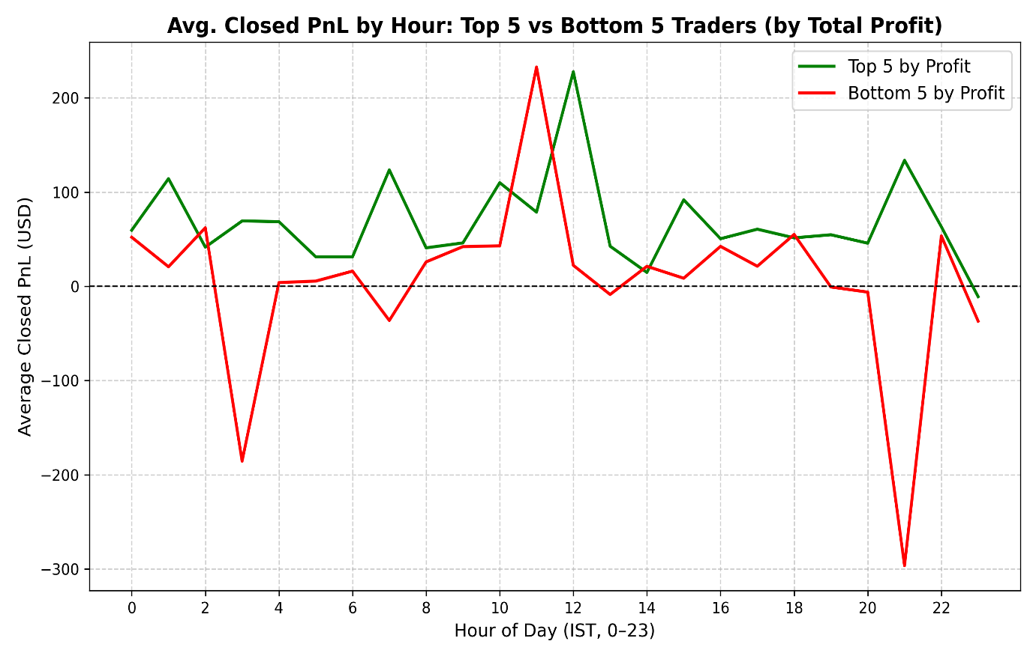

This data shows you the comparison between top 5 trader and bottom 5 trader based on per day profit and loss.

Now as we can see that on an average the profit hour is similar for both the top 5 and bottom 5 trades the only difference that lead to those 5 in bottom is the extra loss in starting and ending due to extra push.

**STRATEGY**

**Positive Profit Hours**

* + Identify hours where the Top-5 line is well above zero (e.g. 9–12 IST).
  + **Rule:** Increase position size when trading in those windows.

**Negative Risk Hours**

* + Hours where the Bottom-5 line falls below zero (e.g. around 3 AM and 9 PM IST).
  + **Rule:** Either *sit out* (no new trades) or cut size drastically (e.g. to 0.5×) during those hours.

**Safe Hours**

* + Hours where *both* Top-5 and Bottom-5 are modestly positive but below your “high‐edge” threshold.
  + **Rule:** Trade at your *baseline* size.

**2.**

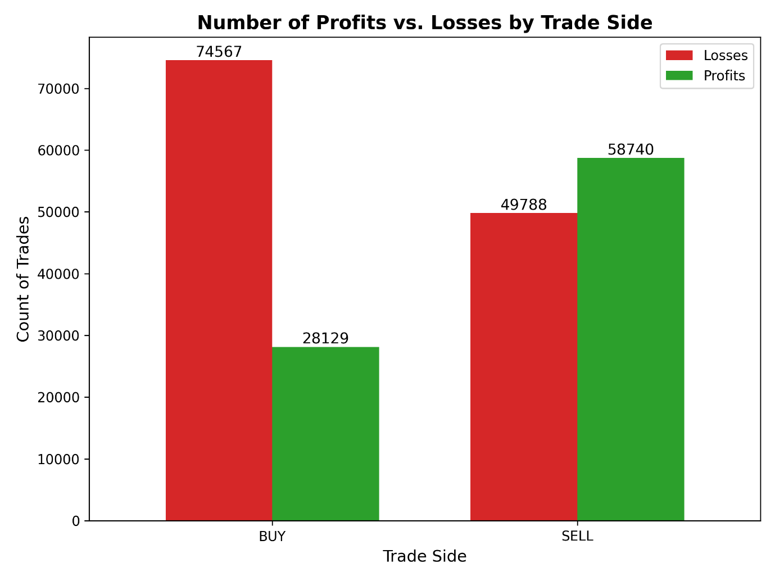

**Risk asymmetry**

* You lose roughly **2.7×** more often on the BUY side than you win.
* On the SELL side, you actually win more often than you lose.

**Volume of trades**

* There are more BUY trades overall (102,696) than SELL (108,528), yet BUY still underperforms.

**STRATEGY**

* As we can see probability of loss is relatively very high in trading in BUY side. Avoiding which can increase the probability.
* Historical win-rate is over **54%**, compared to only **27%** for BUY. Which can also be interpreted as BUY trades lose almost **3 out of 4** times—your risk of ruin is simply too high otherwise.

**3.**

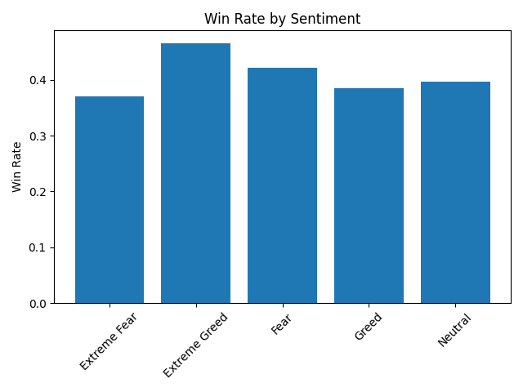

**X-axis (“Sentiment”)**  
Five discrete buckets, from Extreme Fear on the left through Fear, Neutral, Greed, to Extreme Greed on the right. These come from the Fear & Greed Index classification for each trading day.

**Y-axis (“Win Rate”)**  
The fraction of trades on days in each bucket that closed with a Positive PnL. A win rate of 0.45 means 45 % of trades were profitable.

**Bar heights**  
Directly compare how often traders made money when the market was in each sentiment regime.

**STRATEGY**

Summing up how to react on which type of market

**Extreme Fear**

* Typical trade ends around $0 (the middle line).
* Worst trades can lose you nearly $9; best trades can gain you around $14.

**Fear**

* Looks similar to Extreme Fear, but the box is a bit tighter—most trades lose up to $8 or gain up to $14.
* You’re still “shooting in the dark,” so typical profits are low and losses can be painful.

**Neutral**

* Now your “usual” trade (middle line) is slightly above $0.
* Most trades earn between about –$6 and +$10.

**Greed**

* Your typical trade climbs higher—middle line around $0–$1, but the top of the box near $5.
* The best trades can make you more than $12, while the worst cost about $7.

**Extreme Greed**

* Biggest opportunity: the middle line jumps up to ~$0–$2, and most trades land between $0 and $10.
* Bottom trade can still take your loss to –$15, so risk grows too.

**When everyone’s scared (Extreme Fear/Fear),** you’re unlikely to make big gains. Most trades barely break even or lose money.

**When everyone’s neutral,** things calm down—you won’t win huge, but you also won’t lose as much.

**4.**

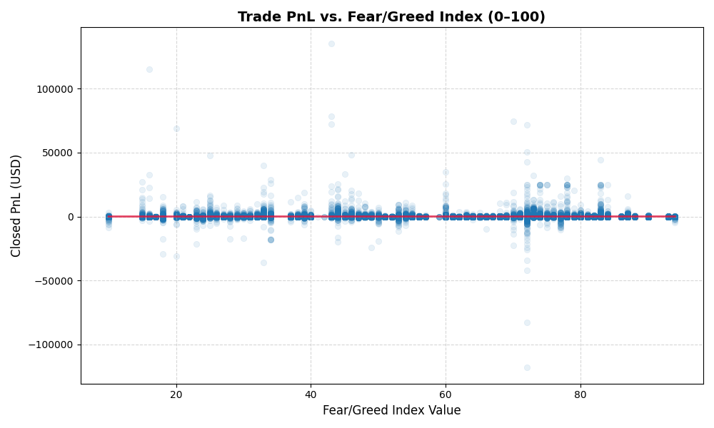

With the help of this data you can tell look at outliers and also give you the sense about intensity of data around areas. As we can see in this plot that the density of the data is most in the center of Y-axis or at 0 closed pnl.

**STRATEGY**

* **Trade Only When Trend Is Positive**
  + If the LOWESS line is above $0 (roughly sentiment > 40), your historical edge is positive. You’d choose to be in the market in that window.
* **Scale by Sentiment Value**
  + You might set position size proportional to the red‐line height:
    - At index 50 (avg PnL ≈ $5), risk 1% of your account.
    - At index 80 (avg PnL ≈ $20), risk 1.5% or 2%.
* **Filter Out Low‐Sentiment Trades**
  + Reject signals when sentiment < 30, because history shows you’ll likely lose money on average.

**5.**

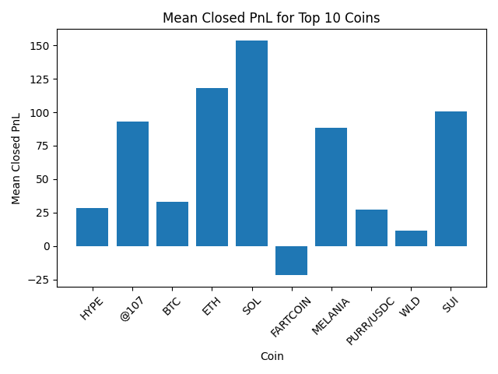

This data shows the mean of closed Profit and loss.

From the given data the thing we can extract is that SOL(solana) is one the best coins to invest statistically. As the pnl mean in highest for it amoung all other.

Contrasting of which FARTCOIN has the worst average/mean for Closed PnL meaning most of the trader who trade in it go through loss most of the time.

**STRATEGY**

* Try trading in coins with better mean in clossed pnl. Based on this data you can tell which coin tends to be most volatile. Although this can be an overlooked scenerio as maybe it is possible that only bottom or new traders trade in this coin which results in such low mean Clossed PnL.